UNIVERSITY OF BUEA

FACULTY OF ENGINEERING AND TECHNOLOGY
DEPARTMENT OF COMPUTER ENGINEERING

CEF440: Internet Programming and Mobile Programming
COURSE INSTUCTOR: Dr. Valery Nkemeni

TASK 5: UI DESIGN AND IMPLEMENTATION

BY GROUP 3

NAMES | MATRICULE
- ABONGWA CALEB NFORNGWA | FE22A133
- BEKONO AKONO MARTHE LUNYA LAWRICA | FE22A171
- MUKETE ATIA HANS MASANGO | FE22A250
- NGUIMFACK AZAFACK JOREL | FE22A267

Academic Year (2024/2025)
TABLE OF CONTENTS
TASK 5: UI DESIGN AND IMPLEMENTATION 1
INTRODUCTION 2
App Identity 3
App Name 3
Purpose and Branding 4
Target Audience 4
Visual Design 4
Design Principles 4
Key screen and layout. 5
Dashboard Screen 5
Feedback form Screen 6
Report History Screen 6
Setting Screen 7
Alert Screen 8
Visual Element 8
Frontend Implementation 9
Technology stacks 9
Third Party Services 9
Key Components 10
Testing and Usability 10
Dashboard Component 10
Feedback Component 10
Setting Component 11
Network Monitoring 12
Implementation Consideration 13
Conclusion 14

Introduction
In today’s digital society, mobile connectivity plays a central role in education, business, health, and social communication. However, mobile subscribers in Cameroon and many other developing regions often face unreliable and inconsistent network performance. The perceived quality of experience (QoE) by users varies depending on multiple dynamic factors like signal strength, latency, and data speed. To address this challenge and empower subscribers, operators, and regulators, this project implements a cross-platform mobile application designed to monitor, report, and visualize mobile network performance from the end-user's perspective.
This report outlines the UI design and implementation of the application named "Checkin", developed as part of Task 5 for the CEF440 course. It builds upon prior system modeling (Task 4), translating conceptual designs into working UI components that are usable, accessible, and visually appealing. The report details the app’s branding identity, visual design principles, Frontend development stack, usability testing strategies, and concludes with an assessment of its real-world applicability.

APP IDENTITY
Definition: Unique elements distinguishing the app, including name, logo, branding, and personality.

App Name
Checkin: Reflects the core purpose of monitoring Quality of Experience (QoE) for mobile networks, ensuring clarity for users, operators, and regulators.

Purpose and Branding
Purpose: To empower users to monitor network performance (speed, latency, signal strength), submit feedback on issues, and receive alerts, while enabling operators and regulators to analyze and improve service quality.
Branding:
- Tagline: "Empower Your Connection" – Emphasizes user control and network transparency.
- Logo: A modern, minimalist design featuring a signal bar icon merged with a checkmark, symbolizing reliable network monitoring and feedback.
Color Scheme:
- Primary: #2E7D32 (deep green) – Trust, reliability, and growth.
- Secondary: #1565C0 (vibrant blue) – Technology and connectivity.
- Accent: #FFD54F (bright amber) – Alerts and user engagement.
Typography: Use clean, modern fonts like Roboto (Android) or San Francisco (iOS) for readability and consistency across platforms.
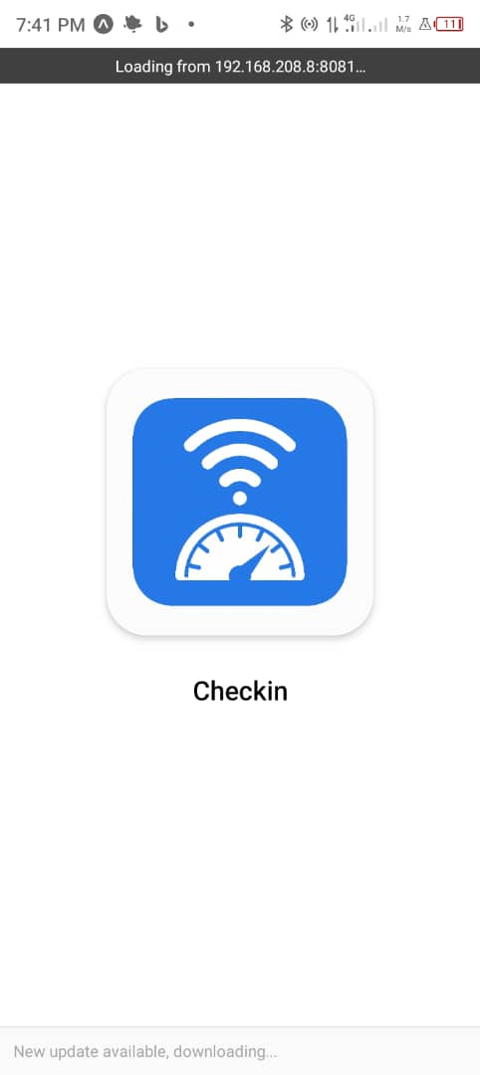
The image above represent the app logo and contains the app name.

Target Audience
- Users: Mobile network subscribers seeking to track and report network performance.
- Network Operators: Staff needing aggregated reports for diagnostics and improvements.
- Regulatory Authorities: Entities requiring anonymized data for compliance and monitoring.
Tone: Professional, user-friendly, and transparent to build trust and encourage interaction.

Visual Design
Definition: Aesthetics, layout, and UI elements ensuring appeal and usability.

Design Principles
- Clarity: Simple layouts and intuitive navigation to ensure users can easily submit feedback, view stats, and adjust settings.
- Consistency: Uniform colors, fonts, and iconography across all screens for a cohesive experience.
- Accessibility: High-contrast colors (e.g., deep green text on white background), scalable text sizes, and support for screen readers to comply with WCAG 2.1 standards.
- Responsiveness: Adaptive design for various screen sizes (phones, tablets) using React Native for cross-platform compatibility.

Key Screens and Layouts
1. Dashboard Screen
Purpose: Displays real-time network stats (speed, latency, signal strength) and quick access to feedback and settings.
Elements:
- Header: App logo, title, and user profile icon.
- Network Stats: Visual cards with metrics (e.g., "Download: 25 Mbps", "Latency: 30 ms").
- Quick Actions: Buttons for "Submit Feedback" and "View History".
Style: Green and blue cards with white text, amber accents for alerts.
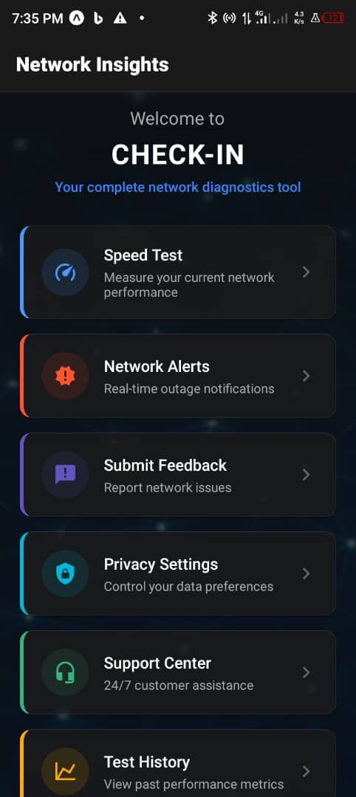
The image above shows the dashboard of the system

2. Feedback Form Screen
- Purpose: Allows users to report network issues.
- Elements:
- Input Fields: Rating (1-5 stars), text area for comments, optional screenshot upload.
- Location Toggle: Option to include geolocation (with permission prompt).
- Submit Button: Prominent, amber-colored for emphasis.
- Style: Clean white background, green borders, clear labels.
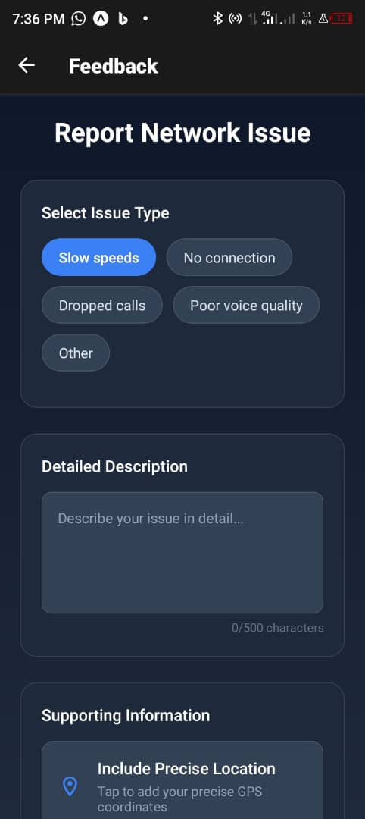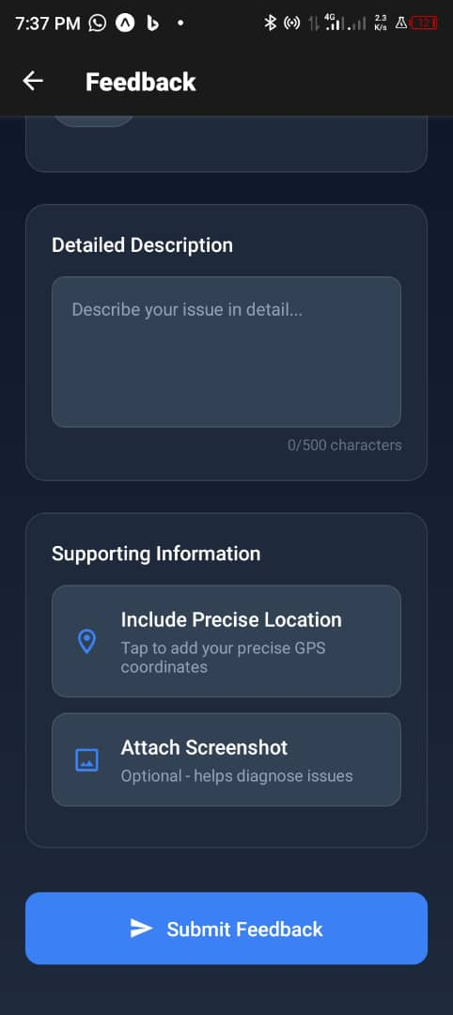
The above image illustrate the feedback page of the app
- Report History Screen
- Purpose: Shows past feedback submissions and their status.
- Elements:
- List View: Scrollable list of reports (date, issue, status—e.g., "Pending", "Resolved").
- Filter Option: Sort by date or status.
- Style: Card-based layout, blue links for details, green status indicators.

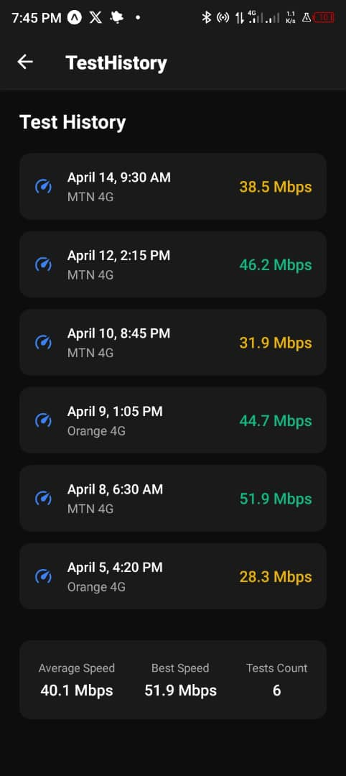
The above image illustrate the Test History page of the app

- Settings Screen
Purpose: Manages user preferences.
Elements:
- Toggles: Data sharing, notifications, and location access.
- Dropdown: Language selection (e.g., English, French).
- Save Button: Green, prominent.
- Style: Minimalist, high-contrast text, grouped sections for clarity.
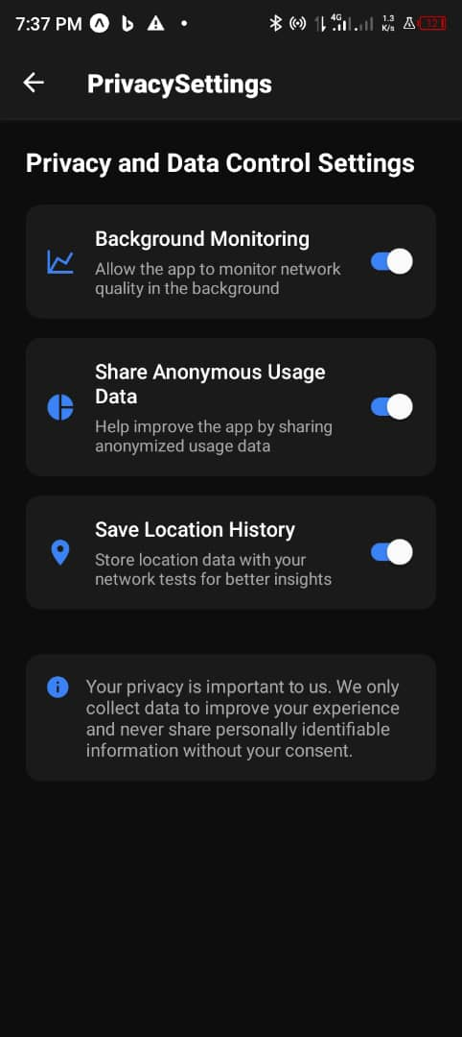

The above image illustrate the privacy settings page of the app

5. Alerts Screen
Purpose: Notifies users of network issues or updates.
Elements
- Notification List: Timestamp, message (e.g., "Low signal detected at 03:34 AM WAT").
- Dismiss Option: Clear individual or all alerts.
- Style: Amber highlights for urgent alerts, white background for readability.
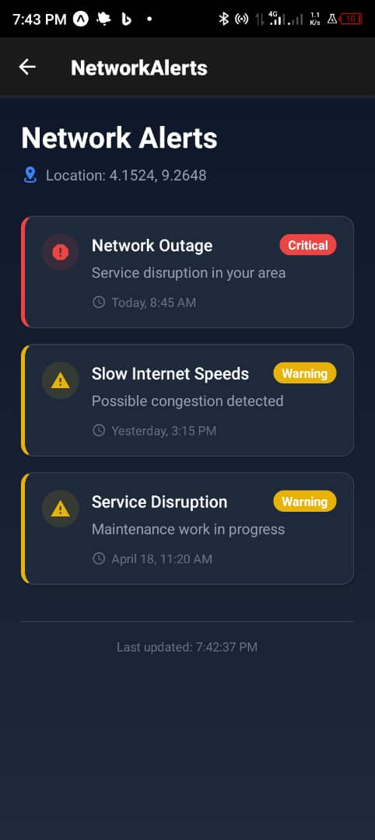

The above image shows the network alert page of the app

Visual Elements
Icons: Simple, flat icons (e.g., signal bars for network, speech bubble for feedback, gear for settings) from a library like Material Icons.
Images: Minimal use, except for user-uploaded screenshots in feedback.
Charts: Real-time network stats visualized (e.g., line chart for speed over time) with green and blue lines, amber for thresholds.
Spacing and Alignment: 16px padding, 8px margins for consistency, centered buttons, and left-aligned text for readability.

Frontend Implementation
Definition: Development of functional UI components.
Technology Stack
- Framework: React Native for cross-platform (Android, iOS) mobile app development, ensuring code reuse and consistent UI.
- State Management: Redux for managing network stats, user feedback, and settings across screens.
- Localization: i18n library for language support (English, French) based on user preferences.
- Backend Integration: RESTful API calls (HTTPS) to the Cloud Server (Node.js + Express) for feedback submission, metrics, and notifications.
Third-Party Services:
Firebase: Authentication, push notifications, and analytics.
Geolocation: React Native Geolocation Service for location data.
Background Tasks: WorkManager (Android) and BackgroundTasks (iOS) for periodic network monitoring.
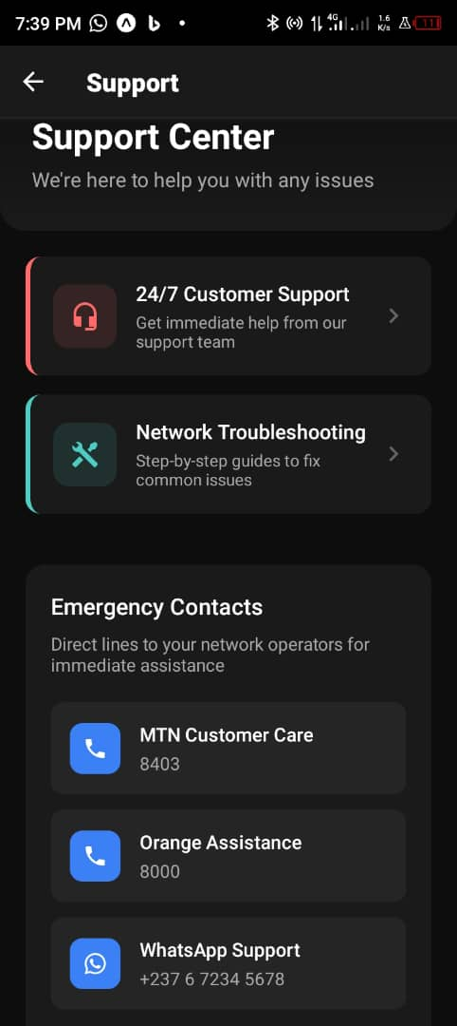
Key Components:
Dashboard, Feedback Form, Settings, Dark Mode Toggle
Implementation Notes:
- Navigation (React Navigation/Router)
- Caching with Redux
- AES-256 encryption, Firebase SDK
- Modular and scalable design

Testing and Usability
Definition: Testing ensures the app functions correctly, while usability evaluates how easy and intuitive the app is for users to interact with.
- Prototyping:Created in Figma to visualize user flow and layout.
- User Testing:Conducted to refine usability and accessibility features.
- Responsive Design:App adjusts gracefully across different devices and screen sizes.
- Automated Testing:

Key Components
1. Dashboard Component
File: `Dashboard.js`
Functionality: Fetches real-time network metrics via API, displays them in cards, and provides navigation to feedback and history.
2. Feedback Form Component
File: `FeedbackForm.js`
Functionality: Collects user input (rating, comments, location), validates, and submits to the Cloud Server via API.
Features: Client-side validation, geolocation permission, file upload for screenshots.

3. Settings Component
File: `Settings.js`
Functionality: Manages toggles and dropdowns for preferences, saves to Redux store and syncs with backend.
Features: Real-time updates, localization support for English/French.

4.Network Monitoring
File: `NetworkMonitor.js`
Functionality: Runs in the background using WorkManager/BackgroundTasks to measure speed, latency, and signal, then updates the Redux store and database via API.
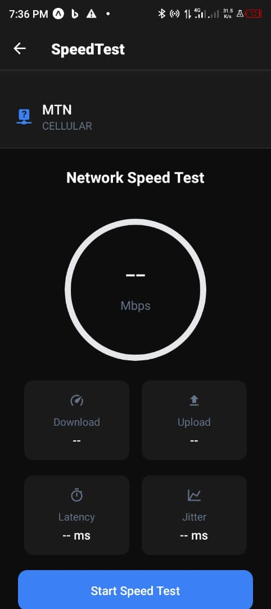

The image above show how network speed id monitored

Implementation Considerations
Navigation: Use React Navigation for stack-based navigation between screens (Dashboard → Feedback → History → Settings → Alerts).
Performance:
- Cache network metrics locally using Redux to reduce API calls.
- Batch database updates for efficiency, as noted in the Sequence Diagram.

Security:
- Encrypt sensitive data (feedback, location) before transmission using AES-256.
- Use HTTPS for API calls and Firebase SDKs for secure notifications.
Testing:
- Unit tests for components (e.g., Jest for React Native).
- Integration tests for API connectivity and background tasks.
- UI testing for responsiveness across devices (e.g., iPhone, Android phones).
- Scalability: Modular components and API-driven design allow for future features like operator responses or advanced analytics.

Conclusion
The UI design and implementation for the "Checkin" app demonstrate a thorough translation of user-centric design principles into a real-world application. From identity and branding to responsive components and cross-platform support, the app addresses the core goal of enhancing mobile network quality visibility in Cameroon. With a solid technical foundation, intuitive layout, and security-focused architecture, this work extends the system modeling phase into a practical, deployable product that can benefit users, operators, and regulatory stakeholders alike.

